Design Models
Learning Objective
Choose appropriate learning theories and design models for the course.
(n): The process by which instruction is improved through the analysis of learning needs and systematic development of learning materials. Instructional designers often use technology and multimedia as tools to enhance instruction.
Understanding by Design (UbD) was created by Wiggins and McTighe and suggests that learning experiences should be planned with the final assessment in mind.
There are three stages to backward design
- Identify Desired Results
- Determine Acceptable Evidence of Learning
- Design Learning Experiences and Instruction
An important consideration when using UbD is to refrain from “teaching to test”.
The ADDIE first appeared in 1975. It was created by the Center for Educational Technology at Florida State University for the U.S. Armed Forces (Branson, Rayner, Cox, Furman, King, Hannum, 1975; Watson, 1981). The model consists of the following 5 steps: Analysis, Design, Development, Implementation, and Evaluation and has been a standard model for the development of multimedia in learning. The model has some inherent weakness the biggest of which is that it does not include an iterative feedback loop for the improvement of design. Everything you every wanted to know and more about this model can be found at http://www.nwlink.com/~donclark/history_isd/addie.html
The Dick and Carey Systems Approach Model was first published in 1978 and is still used today. Perhaps the most important impact of this model on instructional design is that it considers the system around the design and not isolated pieces.
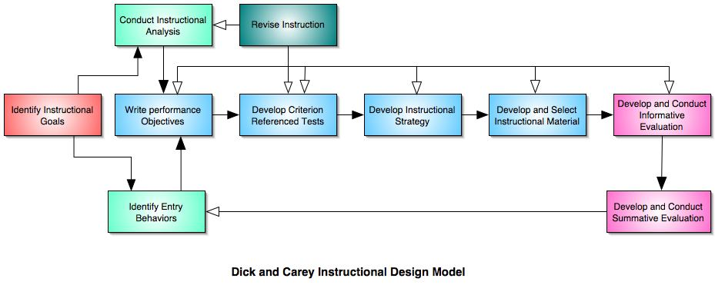
Several theorists emphasize the importance of feedback in the process of instructional design. Spiral Design/ successive approximation/prototype theory are all models that include feedback as an integral part of the design process. Below is a diagram of Michael Allen’s three-iteration application of successive approximation.

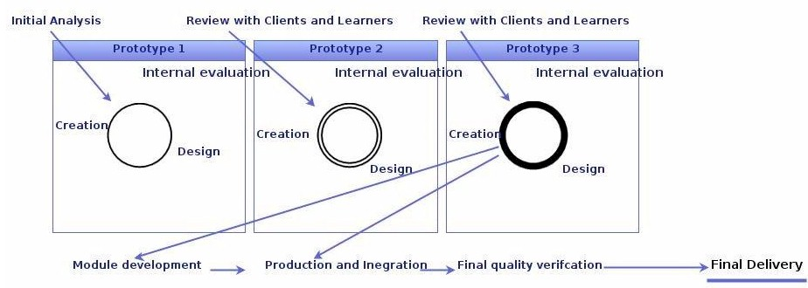
A great website for more information about instructional design is www.instructionaldesign.org
References
Allen, M. (2003). Guide to e-Learning. Building Interactive, Fun, and Effective Learning
Programs for Any Company. John Wiley & Sons, Hoboken, NJ.
Branson, R. K., Rayner, G. T., Cox, J. L., Furman, J. P., King, F. J., Hannum, W. H. (1975).
Interservice procedures for instructional systems development. (5 vols.) (TRADOC Pam 350-
30 NAVEDTRA 106A). Ft. Monroe, VA: U.S. Army Training and Doctrine Command, August
1975. (NTIS No. ADA 019 486 through ADA 019 490).
Dick, W., and Carey, L. (1996). The Systematic Design of Instruction, Fourth Edition. Harper
Collins, New York, NY.
Watson, Russell (October 1981). Instructional System Development. In a paper presented to the
International Congress for Individualized Instruction. EDRS publication ED 209 239.
Wiggins, G., McTighe, J. (2005) Understanding by Design, 2nd Edition. Association for
Supervision and Curriculum Development, Alexandra, VA.

